Software Requirements Specification
for
Smart Traffic Management System
Version 1.0 approved

Prepared by

Amulya P(1MS22MC005)

Komal S Kallanagoudar(1MS22MC016)

M. S. Ramaiah Institute of Technology

30th January, 2024
Table of Contents
Table of Contents ii
Revision History iii
1. Introduction 1
1.1 Purpose 1
1.2 Document Conventions 2
1.3 Intended Audience and Reading Suggestions 2
1.4 Product Scope 2
1.5 References 2
2. Overall Description 3
2.1 Product Perspective 3
2.2 Product Functions 3
2.3 User Classes and Characteristics 4
2.4 Operating Environment 5
2.5 Design and Implementation Constraints 5
2.6 User Documentation 6
2.7 Assumptions and Dependencies 6
3. External Interface Requirements 9
3.1 User Interfaces 9
3.2 Hardware Interfaces 10
3.3 Software Interfaces 11
3.4 Communications Interfaces 12
4. System Features 13
4.1 Density based Traffic Management with Dynamic green signal timing……………………………………….13
4.2 Emergency Vechicle Detetction 15
5. Other Nonfunctional Requirements 22
5.1 Performance Requirements 22
5.2 Safety Requirements 22
5.3 Security Requirements 23
5.4 Software Quality Attributes 23
5.5 Business Rules 24
6. Other Requirements 25
Appendix A: Glossary 26
Appendix B: Analysis Models 26

Revision History
Name | Date | Reason For Changes | Version

Introduction
The following subsections of the Software Requirements Specifications (SRS) document provide an overview of the entire Project. Traffic system utilize the concept of automation with IoT is called as “Smart Traffic”. Smart Traffic Management System is an advanced and integrated solution designed to optimize traffic flow, reduce congestion, enhance road safety, and improve overall transportation efficiency within urban or metropolitan areas.
This system relies on various sensors placed strategically throughout the road network to monitor traffic conditions. The system can control traffic signals at intersections dynamically based on real-time traffic data. Adaptive traffic signal systems adjust signal timings to minimize waiting times and reduce idling. Reducing congestion and energy consumption at intersection. Ensuring immediate clearance for emergency vehicles. Facilitating safer and shorter commute time. The traffic light system has also been given an emergency mode, which gives ambulances priority to pass through traffic lights.

Purpose
A prototype is proposed for a traffic management system using Ultrasonic sensors, Arduino, and LED displays. The density of the traffic is measured by placing the Ultrasonic sensors (HC-SR04) at the 4-lane junction after a certain distance. The data collected from sensors is used to dynamically change the sequence of green lights as well as to dynamically change the green light delays. The proposed road traffic management system is implemented in the proteus software. For high traffic zone, a higher green light delay is given whereas for low density zone, the duration of the green light delay is reduced. The system is also designed in such a way as to give preference to the lanes which have no vehicles/very few vehicles by providing the least green light delays.
Also there will be radio frequency reader on roadside to read the radio frequency tag on an ambulance or fire-extinguisher truck and immediately open the barricade irrespective of what the signal is for that road. Red LED indicates CLOSED and green LED indicates OPEN. Arduino board and radio frequency reader placed on roadside will be used for this purpose. This reader will read and scan the radio frequency tag placed on the emergency service vehicles and signal the Arduino board to halt its normal operation and open the right lane barricade so that the intended emergency vehicle can pass the road junction. This will also reduce the number of accidents occurring due to violation of traffic rules by passing the road junction during the stop signal. For implementation, we are using Arduino-Mega and RFID technology. The system has the ability to open a complete lane for such emergency cases.

Document Conventions
The document was created based on the IEEE template for System Requirements Specification Document.

Intended Audience and Reading Suggestions
The Software Requirements Specification for the Smart Traffic Management System is designed to cater to diverse reader types. Developers will focus on technical details, project managers on scope and timelines, marketing staff on features, users on operational guidance, testers on test cases, and documentation writers on terminology. The document is organized with an introduction, system overview, scope, functional and non-functional requirements, database design, system architecture, user manual, testing details, and project timeline. A suggested reading sequence starts with the introduction, with subsequent sections tailored to each reader's primary interests and responsibilities.

Product Scope
A Smart Traffic Management System utilizing the Internet of Things offers real-time traffic monitoring, adaptive signal control, and smart parking solutions to optimize urban mobility. Connected vehicles receive traffic alerts and contribute to dynamic route planning, while data analytics enable data-driven decision-making for infrastructure improvements. The system enhances public safety through incident detection and pedestrian-friendly features. Integration with other smart city components creates a comprehensive urban development approach. The TMS aims to reduce congestion, improve fuel efficiency, and minimize environmental impact, fostering cost savings and overall transportation efficiency in smart cities.

References
- https://www.jetir.org/papers/JETIR2104274.pdf
- https://ieeexplore.ieee.org/abstract/document/8975582/
- https://www.ijcrt.org/papers/IJCRT1892564.pdf
- https://www.irjmets.com/uploadedfiles/paper/issue_7_july_2022/28863/final/fin_irjm ets1658977133.pdf
- https://iopscience.iop.org/article/10.1088/1742-6596/2466/1/012025/pdf

Overall Description

Product Perspective
A smart parking system using IoT optimizes parking space utilization by employing sensors and connectivity to monitor real-time availability. Users benefit from a mobile app that facilitates reservations, navigation to open spaces, and contactless payments. The system's data analytics offer insights into usage patterns, aiding urban planning decisions. Integration with navigation systems, predictive maintenance, and environmental considerations enhance overall efficiency. Emphasis on security, privacy controls, scalability, and regulatory compliance ensures a comprehensive, user-friendly, and adaptable solution for efficient urban mobility.
The system's inherent data analytics capabilities contribute significantly to urban planning by offering valuable insights into parking usage patterns. This data-driven approach facilitates informed decision-making for city planners, helping them optimize parking infrastructure based on actual demand. The integration of the smart parking system with navigation systems adds another layer of efficiency, allowing users to seamlessly incorporate parking availability information into their travel routes. This integration contributes to reducing traffic congestion and enhancing overall mobility in urban areas.

Product Functions
- Vehicle Detection.
- Emergency Vehicle Detection.
- Congestion Control.
- Scalability.
- Modular Architecture.
- Security Measures.
- Predictive Maintenance.
- Environmental Monitoring.

User Classes and Characteristics
A smart traffic management system using the Internet of Things (IoT) caters to various user classes with distinct characteristics. These user classes play specific roles and interact with the system differently. Here are some key user classes and their characteristics in a smart traffic management system:

- Traffic Authorities:
Characteristics: Government agencies, traffic control centers, and law enforcement.
Roles: Monitor and control traffic flow, receive real-time data for decision-making, and enforce traffic regulations.
Interactions: Access to comprehensive traffic data, control traffic signals, and receive alerts for emergencies.
- Transportation Planners:
Characteristics: Urban planners, city officials, and transportation departments.
Roles: Analyze traffic patterns, plan infrastructure developments, and optimize transportation systems.
Interactions: Access historical and real-time traffic data for city planning, implement changes based on insights, and assess the impact of transportation policies.
- System Administrators:
Characteristics: IT professionals responsible for maintaining the traffic management system.
Roles: Ensure the system's smooth operation, address technical issues, and perform system upgrades.
Interactions: Monitor system health, troubleshoot problems, and implement updates to improve performance.
- Commercial Fleet Operators:
Characteristics: Companies managing vehicle fleets for transportation and delivery services.
Roles: Optimize route planning, reduce fuel consumption, and enhance overall fleet efficiency.
Interactions: Access real-time traffic data for route optimization, receive alerts for traffic incidents, and integrate with navigation systems.
- Individual Drivers:
Characteristics: Private vehicle owners and drivers.
Roles: Navigate efficiently, avoid traffic congestion, and receive real-time information about road conditions.
Interactions: Use navigation apps for real-time traffic updates, receive alerts on alternative routes, and contribute data through connected devices.
- Pedestrians and Cyclists:
Characteristics: Individuals using non-motorized transportation modes.
Roles: Ensure safe crossings, access pedestrian-friendly routes, and receive alerts on potential hazards.
Interactions: Receive real-time information on pedestrian-friendly routes, crossing times, and safety alerts through mobile apps or connected devices.

- IoT Device Manufacturers:
Characteristics: Companies producing IoT devices and sensors for traffic management.
Roles: Develop and provide sensors for data collection, contribute to technology advancements, and improve system connectivity.
Interactions: Collaborate with system administrators to ensure compatibility, offer updates for IoT devices, and participate in system improvement initiatives.
- Emergency Services:
Characteristics: Firefighters, paramedics, and law enforcement.
Roles: Respond to emergencies, navigate through traffic efficiently, and coordinate responses.
Interactions: Access real-time traffic data for emergency route planning, receive priority signals at intersections, and collaborate with traffic authorities for incident management.

Operating Environment
- Dynamic Lane management.
- Variable speed limits.
- Adaptive Traffic signal control.
- Emergency services.
- Traffic controller cabinet.

Major Components

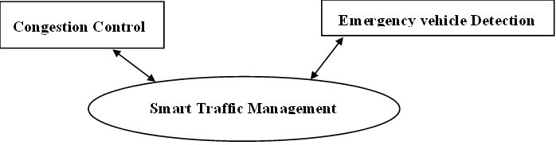

High Level Dataflow Diagram

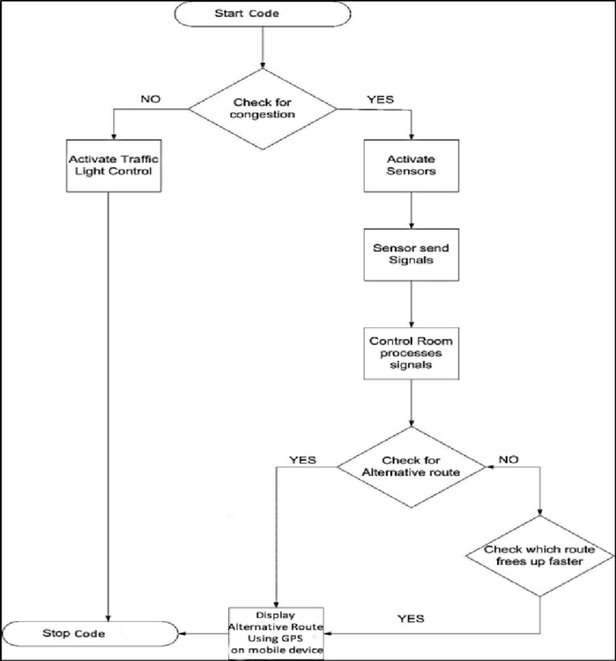

Design and Implementation Constraints
The reliance on network connectivity can lead to performance issues in areas with poor coverage. Protecting sensitive traffic data is crucial to prevent breaches that could compromise privacy and system integrity. Ensuring seamless communication between diverse IoT devices and systems with different protocols is essential. The system must be scalable to handle urban growth and changing traffic patterns effectively. IoT devices, especially in remote areas, may face power constraints, impacting reliability. Budget limitations can affect the system's capabilities and the adoption of advanced technologies. Reliable data from sensors is critical for effective decision-making in traffic management. Adherence to local regulations and data privacy standards is essential to avoid legal issues. Harsh weather conditions can impact the performance of IoT devices and sensors. Public understanding and acceptance of the system are crucial for its success. Compatibility issues may arise when integrating IoT technologies with existing traffic management infrastructure. Continuous data collection can lead to information overload, straining system resources. IoT devices are susceptible to cyber threats, requiring robust cybersecurity measures. Proper training for users, including traffic management professionals and the public, is essential for effective system utilization.

User Documentation
The Smart Traffic Management System using IoT is a technology-driven solution designed to optimize urban traffic control. It employs IoT devices such as sensors and cameras to monitor and analyze real-time traffic data, offering features like dynamic traffic signal control, predictive analytics, emergency response systems, and historical data analysis.
The Key Components are:
- Overview
- System Architecture
- Getting started
- User Interface
- Features
- Trouble shooting
- Security
This documentation serves as a guide for users, offering detailed information on setup, features, troubleshooting, security measures, and ongoing maintenance of the Smart Traffic Management System using IoT.

Assumptions and Dependencies
Assumptions and dependencies play a crucial role in the development of a Smart Traffic Management System (TMS). Here are some examples that might be relevant to your project:

Assumptions:
- Data Accuracy: Assuming that the data received from various sensors is accurate and reliable. Inaccurate data could lead to incorrect traffic management decisions.
- Network Reliability: Assuming a stable and reliable network connection for communication between different components of the system. Unreliable network connectivity could impact real-time decision-making and communication among different system modules.
- Compliance with Regulations: Assuming that the implementation of the traffic management system complies with local traffic regulations and legal requirements. Changes in regulations could affect the system's functionality.
- Weather Conditions: Assuming normal weather conditions for the proper functioning of outdoor sensors and equipment. Extreme weather conditions might impact the accuracy of sensor data.
- User Cooperation: Assuming that drivers and pedestrians will cooperate with the system recommendations. Unpredictable human behavior could affect the overall effectiveness of the traffic management system.

Dependencies:
- GIS Data: Dependency on accurate Geographic Information System (GIS) data for mapping and route planning. Changes in road layouts or infrastructure should be reflected in the GIS data.
- Weather API: Dependency on a reliable weather API for real-time weather updates. Weather conditions influence traffic patterns and may require adjustments in the management strategy.
- Traffic Signal Hardware: Dependency on functional and compatible traffic signal hardware for implementing changes in signal timings. Integration issues with existing infrastructure could impact the deployment.
- Mobile App Platforms: If the system includes a mobile application for users, there might be a dependency on the stability and compatibility of mobile app platforms (iOS, Android).
- Government Support: Dependency on the support and cooperation of local government authorities for the implementation and maintenance of the system. Lack of support may hinder the system's effectiveness.

External Interface Requirements

User Interfaces
- Administrators: Responsible for system configuration, monitoring, and making high-level decisions.
End-users (Drivers and Pedestrians): Interact with the system through various channels like mobile apps, in-vehicle displays, or roadside displays.
- Administrator Interface
The administrator interface includes the following elements:
Dashboard: A centralized overview of the current traffic conditions, system status, and alerts.
Configuration Panel: Allows administrators to configure system parameters, set traffic policies, and manage user access.
Reporting and Analytics: Provides tools for generating reports and analyzing historical traffic data.
- End-User Interface
The end-user interface components will vary depending on the platform (mobile app, in-vehicle display, roadside display). Common elements include:
- Real-Time Traffic Information
Display of current traffic conditions, including congestion, road closures, and alternative routes.
Navigation Assistance: Turn-by-turn navigation with real-time updates based on traffic conditions.
Alerts and Notifications: Visual and auditory alerts for important traffic information and updates.
- Interface Standards
The user interface will adhere to the following standards:
Consistency: Maintain a consistent design across all interfaces for a seamless user experience.
Accessibility: Ensure the interface is accessible to users with disabilities, following relevant accessibility standards.
Responsive Design: Design interfaces to be responsive, adapting to various screen sizes and resolutions.
- Screen Layout Constraints
The layout of screens will adhere to established design principles, optimizing for clarity and ease of use. Considerations include the placement of critical information, use of color for traffic status indicators, and the organization of navigation elements.
- Error Handling:
Standardized error messages will be implemented, providing clear and actionable information to users in case of errors or system issues.
- Help and Documentation
A help feature and documentation will be available within the user interface to assist users in understanding system functionality and troubleshooting common issues.
- Security
User authentication and authorization mechanisms will be integrated into the interface to ensure secure access and protect sensitive information.

Hardware Interfaces
The hardware infrastructure for a smart traffic management system using IoT comprises various components, including sensors, RFID tags, traffic signal controllers, a communication network, edge computing devices, a central server, user interface devices, power supply systems, weather-resistant enclosures, security measures, scalability features, redundancy and fault tolerance mechanisms, remote monitoring and maintenance capabilities, and integration with emergency systems. This comprehensive system is designed to monitor and manage traffic conditions effectively, ensuring real-time responsiveness, enhanced safety, and reduced congestion. Regular maintenance and updates are essential to sustain the system's functionality and effectiveness over time.

- HC-SR04 Ultrasonic sensor
The HC-SR04 ultrasonic sensor is commonly used for distance measurement and might not be the most suitable sensor for tracking traffic flow, vehicle count, and speed. However, if you want to experiment with the HC-SR04 sensor for basic distance measurements, you can use it to detect the presence of vehicles. Keep in mind that using a variety of sensors, including radar sensors and cameras, would be more effective for a comprehensive traffic management system.
- Traffic Signal Controllers
Implement intelligent traffic signal controllers that can dynamically adjust signal timings based on real-time traffic conditions. Connect these controllers to the central management system through a communication network.
- Communication Network (Jumper wires)
Establish a robust communication network to connect all the hardware components. This may include wired connections. Ensure secure and reliable communication for transmitting real-time data between sensors, controllers, and the central system.
- Power Supply
Ensure reliable power supply for all devices, considering backup options such as batteries or generators to prevent system failures during power outages.

- RFID-Tags
Using RFID (Radio-Frequency Identification) tags to detect emergency vehicles is a viable solution for traffic management systems. RFID technology allows for wireless communication between a tag (attached to the emergency vehicle) and a reader located at a specific point in the road infrastructure.
- Traffic LED
Integrating traffic LEDs (Light Emitting Diodes) into a smart traffic management system can enhance the efficiency of traffic control and communication. Connect traffic LEDs to intelligent traffic signal controllers that are part of the overall smart traffic management system. Use real-time data from sensors and cameras to dynamically adjust signal timings and optimize traffic flow. Implement adaptive signal timings based on traffic conditions. Adjust the duration of green, yellow, and red lights dynamically to respond to changing traffic patterns.

Software Interfaces
The Arduino Integrated Development Environment (IDE) is an open-source software platform used for programming and developing applications for Arduino microcontroller boards. Arduino is a popular platform for hobbyists, students, and professionals to create a wide range of electronic projects and prototypes.
Here are some key aspects of the Arduino IDE:
- Cross-Platform: Arduino IDE is available for Windows, macOS, and Linux, making it accessible to a broad user base.
- Code Editor: It provides a text editor where you can write, edit, and save your Arduino sketches (code) written in C/C++.
- Built-in Libraries: The IDE includes a collection of libraries that simplify interfacing with various hardware components, making it easier to control sensors, displays, motors, and other peripherals.
- Compiling and Uploading: Arduino IDE compiles your code into machine-readable binary files and uploads them to the Arduino board over a USB connection.
- Serial Monitor: It has a built-in serial monitor that allows you to interact with your Arduino projects and view debugging information sent over the serial port.
- Board Manager: Arduino IDE supports various Arduino boards, and you can select the appropriate board from the "Boards Manager."
- Library Manager: You can easily add and manage third-party libraries for additional functionality.
- Examples: The IDE provides a variety of example sketches to help you get started with different hardware and programming tasks.

Communications Interfaces
For the communication interface in your smart traffic management system using Arduino and various sensors/controllers, you can utilize a combination of wired and wireless communication protocols. Here's an outline of the communication interfaces you might consider:

- Wired Communication
Serial communication using UART (Universal Asynchronous Receiver-Transmitter) is a common and straightforward method to enable data exchange between different Arduino boards. UART allows for two-way communication between devices, using two wires: one for transmitting data (TX) and another for receiving data (RX).

- Wireless Communication
RFID (Radio-Frequency Identification) communication is a wireless technology that enables data exchange between RFID readers and RFID tags. In the context of a smart traffic management system, RFID communication can be employed to detect and prioritize emergency vehicles at intersections.

System Features
A prototype is proposed for a traffic management system using Ultrasonic sensors, Arduino, and LED displays. The density of the traffic is measured by placing the Ultrasonic sensors (HC-SR04) at the 4-lane junction after a certain distance. The data collected from sensors is used to dynamically change the sequence of green lights as well as to dynamically change the green light delays. The proposed road traffic management system is implemented in the proteus software. For high traffic zone, a higher green light delay is given whereas for low density zone, the duration of the green light delay is reduced. The system is also designed in such a way as to give preference to the lanes which have no vehicles/very few vehicles by providing the least green light delays.

Density based Traffic Management with Dynamic green signal timing
4.1.1 Description and Priority
The ultrasonic sensors are kept at some distance from the junction which collects the data and are used to detect the density of the traffic in a particular lane. If traffic extends up to that point, that road is considered as a high traffic zone, otherwise it is considered as a low traffic zone. If any data comes from Ultrasonic sensor of any road, it means traffic is more on that road. So, green signal is given to the road having high density rather than following the normal sequence as before.

Stimulus/Response Sequences
- Stimulus: Ultrasonic Sensor Data Received
The system responds to ultrasonic sensor data from a specific road junction, measuring the density of traffic in a lane. It analyzes the data in real-time, updating visualizations and issuing alerts for congestion. The system may adjust traffic signal timings, log historical data, notify users of delays, and coordinate with emergency services if needed. Overall, it enables proactive traffic management and provides timely information to both authorities and users.
- Response: Traffic Density Analysis
The system processes the ultrasonic sensor data to determine the traffic density in the lane. Depending on whether the density surpasses a predefined threshold, it classifies the road as either a high traffic zone or a low traffic zone. This decision logic is essential for identifying and categorizing the current traffic conditions, providing a basis for subsequent actions and responses within the Traffic Management System.
- Response: Signal Control Adjustment
If the ultrasonic sensor data designates a road as a high traffic zone, the system responds by adjusting the traffic signal control. This involves granting a green signal to the congested road, prioritizing it over the normal sequential signal rotation. This action aims to optimize traffic flow in real-time, addressing the immediate needs of the high-density traffic zone within the Traffic Management System.
- Response: Traffic Signal Update
Following the adjustment of traffic signal control to accommodate the high traffic zone, the system ensures the updated signal information is communicated to the traffic signal controller at the junction. This step is crucial to implement real-time changes in signal timings, aligning them with the current traffic conditions within the Traffic Management System.

4.1.3 Functional Requirements
- REQ-1: Density Measurement
The system should be able to accurately measure the density of vehicles at each intersection
or road segment in real-time. Utilize sensors such as cameras, radar, or inductive loops to
capture and analyze traffic density.
- REQ-2: Dynamic Signal Timing
Implement an algorithm that adjusts signal timings dynamically based on real-time traffic
density data. Optimize signal timings to minimize congestion, reduce waiting times, and enhance traffic flow efficiency.
- REQ-3: Traffic Light Control
Enable the system to control traffic lights at each intersection. Support the ability to change
signal timings for individual phases (e.g., green, yellow, red) dynamically.
- REQ-4: Integration with Centralized Traffic Management System
Ensure compatibility and integration with a centralized traffic management system if
applicable. Facilitate communication with other traffic management components to
coordinate signals across a wider area.

- REQ-5: Energy Efficiency
Incorporate energy-saving measures, such as dimming traffic lights during low traffic
periods or adjusting signal timings to reduce unnecessary energy consumption.

Emergency Vehicle Detection
4.1.1 Description and Priority
The RFID tags are used to detect emergency vehicles like ambulance. When there is an Ambulance in lane, immediately the Green signal for Ambulance will be given so that Ambulance can be moved without interruption so patients can be reached to hospital as soon as possible. When there is Ambulance in lane 1 and yellow signal for lane 2 is High and after 5 sec delay the green signal for lane 2 has to be high but due to detection of ambulance on lane 1 the green signal for lane 3 will be high and for all other lane's red signal will be High. When the ambulance moves the normal cycle will continue, in this case 2 lane's green signal will be high.

Stimulus/Response Sequences
- Stimulus: Emergency Vehicle Signal
Upon receiving a signal indicating the presence of an emergency vehicle, the system acknowledges this stimulus. The signal, transmitted through specialized communication channels, provides information about the emergency vehicle's location and status. This stimulus triggers the system to initiate appropriate responses, such as giving priority to the emergency vehicle at traffic intersections or dynamically adjusting signal timings to facilitate its swift passage. The data format ensures that the system can effectively interpret and respond to the emergency vehicle signal, contributing to efficient emergency response coordination within the Traffic Management System.
- Response: Emergency Vehicle Detection
The system checks the emergency vehicle signal to confirm if there is indeed an emergency vehicle. It also makes sure that the signal is genuine and not a false alarm to ensure accurate detection. This step prevents reacting to signals that are not from legitimate emergency vehicles, maintaining the system's reliability in identifying real emergencies within the Traffic Management System.
- Stimulus: Emergency Vehicle Passage Confirmation
The system watches the emergency vehicle go through the junction and checks with extra sensors or cameras to make sure it passed successfully. This ensures accurate confirmation of the emergency vehicle's safe passage within the Traffic Management System.
- Response: Normal Traffic Resumption
Once the emergency vehicle has cleared the junction, the system goes back to its normal traffic signal pattern.
4.1.3 Functional Requirements
- REQ-1: Vehicle Identification
The system should be able to distinguish emergency vehicles from regular vehicles. It must
identify different types of emergency vehicles (ambulance, fire truck, police car) accurately.
- REQ-2: Real-time Detection
The system should provide real-time detection of emergency vehicles within a predefined response time. It must continuously monitor the traffic environment for the presence of
emergency vehicles.
- REQ-3: Integration with Traffic Control
The system should seamlessly integrate with existing traffic control systems. It must be capable of communicating with traffic signals to prioritize the passage of emergency vehicles.
- REQ-4: Communication with Emergency Services
The system should be able to communicate detected emergency vehicles' location and status to relevant emergency service centers. It must support standard communication protocols for interoperability with emergency response systems.

High Level Diagrams
Architectural diagram

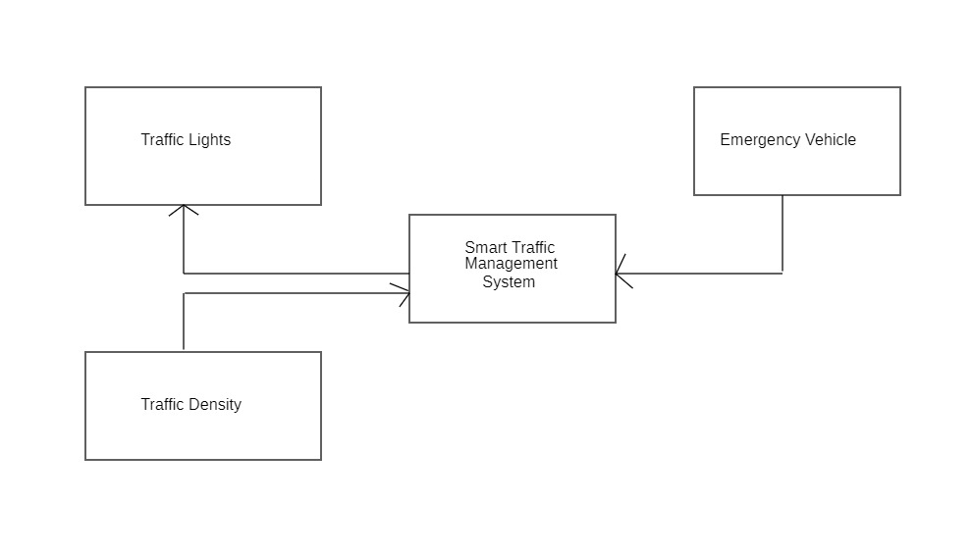

Designing the architectural diagram for smart traffic management system involves visualizing the various components and their interactions.
Components are Traffic sensors, Ultrasonic sensors, Traffic lights, RFID tags
Ultra sonic sensors detect the density of the traffic and the traffic lights are adjusted as per density RFID tags are used to detect the emergency vehicle and tom on the green signal immediately.

Context Model

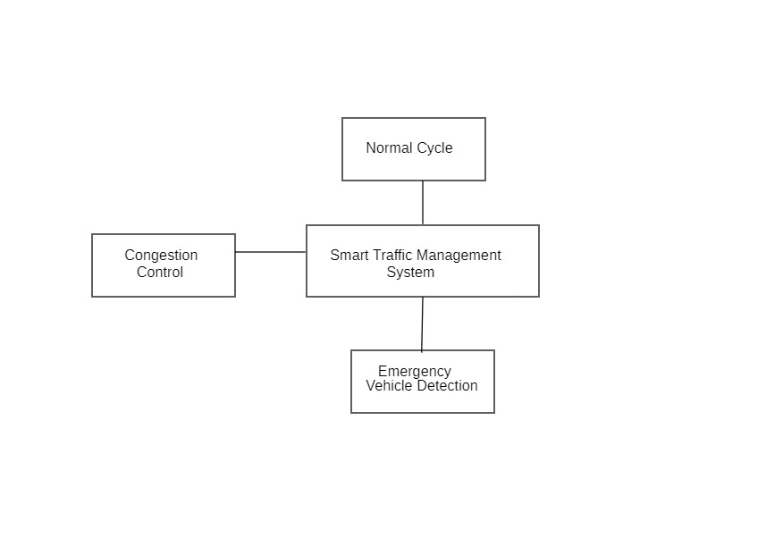

A context diagram for a smart traffic management system shows how it interacts with external elements. Components like "Normal Cycle," "Congestion Control," and "Emergency Vehicle Detection" are depicted to provide a concise overview of their roles in the system.
Normal Cycle: Represents the regular traffic signal operations, indicating the standard flow of traffic.
Congestion Control: Deals with mechanisms and algorithms to manage and alleviate traffic congestion, ensuring smoother traffic flow during peak times.
Emergency Vehicle Detection: Involves technology to identify and prioritize emergency vehicles, enabling swift passage through traffic.
The diagram illustrates how these components interface with each other and external entities, providing a top-level understanding of the smart traffic management system

Use Case Diagram
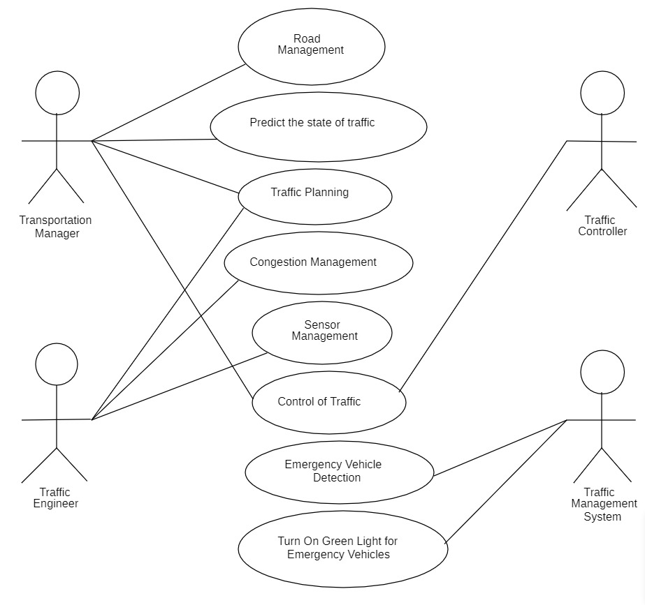
A use case diagram for a Smart Traffic Management System (STMS) can help illustrate the different interactions between actors and the system. In the Smart Traffic Management System, there are three main players: Drivers, Traffic Administrators, and Emergency Services. Drivers use the system to check real-time traffic conditions, get alerts about accidents or road closures, and find alternative routes based on up-to-date information. Traffic Administrators monitor live traffic data, adjust traffic signal timings, and view analytics to improve overall traffic management. Emergency Services utilize the system to access real-time traffic information, enabling them to efficiently manage traffic and respond swiftly during emergencies, such as taking control of signals or suggesting alternate routes. Together, these actors and their actions contribute to a more informed, responsive, and efficient traffic management system.

Low level Diagrams
Sequence Diagram

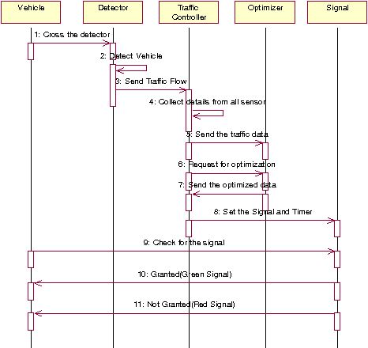
The sequence diagram for traffic management, components include Vehicle, Detector, Traffic Controller, Optimizer, and Signal. The sequence illustrates how a vehicle's presence is detected by a sensor (Detector), triggering interactions between the Traffic Controller, Optimizer, and Traffic Signal to optimize traffic flow efficiently. This process involves real-time adjustments based on detected conditions, ensuring coordinated traffic management at intersections.

State Diagram

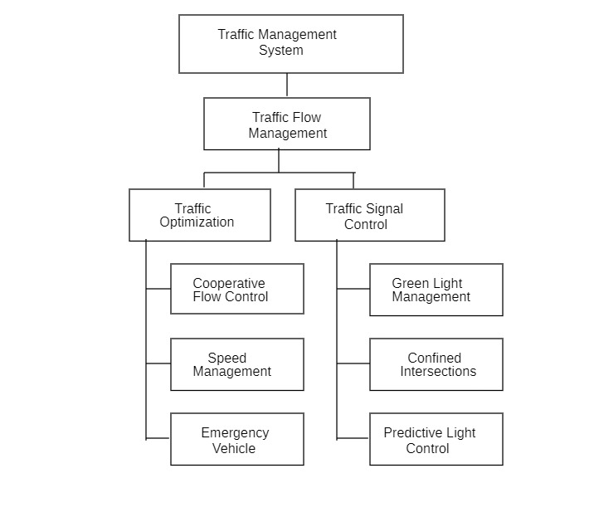

In the state diagram for traffic management, key components include Traffic Flow Management, Traffic Optimization, and Traffic Signal Control. It depicts different states within each component, such as traffic flow conditions, optimization strategies, and signal statuses. The transitions between these states illustrate how the system dynamically responds to changing traffic conditions, optimizing flow and controlling signals for efficient traffic management.

Other Nonfunctional Requirements

Performance Requirements
The smart traffic management system is designed with a set of performance requirements aimed at ensuring its effectiveness in real-time traffic monitoring and control. Firstly, the system is mandated to process real-time traffic data with a latency of less than 1 second. This imperative is grounded in the recognition that timely data processing is pivotal for making swift decisions and adjustments to traffic signal timings. By achieving this requirement, the system ensures that it can dynamically respond to changing traffic conditions, thereby optimizing traffic flow and minimizing congestion on roadways. Emergency vehicle detection represents a critical aspect of the system's functionality, necessitating the system to detect and prioritize emergency vehicles within 5 seconds of their approach. This swift identification and prioritized response are fundamental for ensuring the rapid passage and efficient response of emergency vehicles during critical situations, contributing significantly to public safety and emergency management.
Finally, the system is mandated to dynamically adjust traffic signal timings within 10 seconds of detecting changes in traffic conditions. This requirement reflects the system's adaptive nature, allowing it to quickly respond to traffic fluctuations and optimize signal timings to minimize congestion. This rapid adaptation enhances overall traffic flow efficiency, reducing delays for commuters and contributing to the system's overarching goal of ensuring a smooth and responsive smart traffic management experience.

Safety Requirements
The safety requirement concerning emergency vehicle priority is a pivotal aspect of the smart traffic management system, ensuring the swift and secure passage of emergency vehicles through traffic intersections. The system is mandated to prioritize and facilitate the safe movement of emergency vehicles, recognizing the critical nature of their response during urgent situations.
The requirement for emergency vehicle priority underscores the system's commitment to public safety by streamlining the movement of emergency vehicles through intersections. The activation of preemption mechanisms and clear signaling not only aligns with regulatory expectations but also contributes significantly to the overall effectiveness of emergency response efforts, minimizing response times and enhancing the safety of both emergency personnel and the public.

Security Requirements
The smart traffic management system is fortified with a set of security requirements aimed at safeguarding its integrity, data confidentiality, and overall functionality. Firstly, the system is mandated to implement robust access control mechanisms, ensuring that unauthorized access to sensitive components, data, and functionalities is strictly restricted. By enforcing stringent access controls, the system enhances its resilience against potential security threats, safeguarding critical elements from unauthorized manipulation or compromise. This measure not only contributes to the system's security posture but also aligns with industry best practices for access management.
The system places a strong emphasis on physical security. A specific requirement dictates the implementation of physical security measures, including access controls and surveillance, to protect critical hardware components and infrastructure. This multifaceted approach addresses not only virtual vulnerabilities but also the physical aspects of the system. Access controls and surveillance mechanisms serve as a deterrent to unauthorized physical access, bolstering the overall resilience of the smart traffic management system against both virtual and physical security threats.

Software Quality Attributes
- Usability
The system interface should achieve a usability score of at least 80% in user satisfaction surveys. A user-friendly interface is crucial for operators and administrators to efficiently navigate the system and perform tasks.
- Reliability
The system should have a mean time between failures (MTBF) of at least 99.9% over a one-month period. Reliability is critical for ensuring continuous and uninterrupted traffic management operations, minimizing downtime.
- Maintainability
The system should facilitate software updates and maintenance with no more than 30 minutes of system downtime per month. Ease of maintenance is essential for keeping the system up-to-date and addressing potential issues promptly.
- Adaptability
The system should support the integration of new traffic sensors and devices within one week of their introduction. Adaptability ensures the system can incorporate emerging technologies and expand its capabilities seamlessly.

- Availability
The system should maintain at least 99.5% availability during normal operational hours. High availability is essential for ensuring continuous traffic management operations without significant disruptions.
- Correctness
The system's decision-making algorithms should have an accuracy rate of at least 95% in predicting optimal traffic signal timings. Correctness is crucial for the effectiveness of traffic management decisions and overall system performance.

Business Rules
- Role-Based Access Control (RBAC)
Business Rule: Only authorized personnel, such as traffic administrators and system operators, should have access to configuration settings and administrative functions.
Functional Implication: Implement role-based access control mechanisms to restrict access based on user roles, ensuring that each user can only perform functions aligned with their responsibilities.
- Emergency Vehicle Priority
Business Rule: Emergency vehicles, identified by specific signals or RFID tags, should be given priority at intersections to ensure swift and safe passage.
Functional Implication: Implement a mechanism that detects emergency signals or RFID tags and dynamically adjusts traffic signal timings to provide priority to emergency vehicles.
- Dynamic Traffic Signal Adjustments
Business Rule: The system should dynamically adjust traffic signal timings based on real-time traffic conditions to optimize traffic flow.
Functional Implication: Implement intelligent traffic signal controllers and data analysis algorithms to continuously monitor and adjust signal timings in response to changing traffic patterns.
- Regular Maintenance Checks
Business Rule: Regular maintenance checks should be conducted to ensure the continued functionality and safety of the system.
Functional Implication: Implement a system for scheduled maintenance checks, including software updates, hardware inspections, and performance evaluations.

- Compliance with Traffic Regulations
Business Rule: The system should comply with local traffic laws and regulations, including speed limits, traffic signal rules, and emergency vehicle protocols.
Functional Implication: Ensure that the system's algorithms and functionalities align with regional traffic regulations to promote legal and safe traffic management.

Other Requirements
In today's rapidly evolving urban landscape, effective traffic management has become a paramount concern. The burgeoning populations and escalating vehicular density in cities have fueled a demand for innovative solutions to address the challenges of congestion and mobility. The introduction of the Smart Traffic Management System marks a pivotal shift, presenting a dynamic and responsive framework poised to revolutionize conventional traffic control paradigms.

- Energy Efficiency
The system should be designed to operate efficiently to minimize energy consumption, especially in low-traffic periods. Energy-efficient operation aligns with environmental sustainability goals and reduces overall operational costs.
- Regulatory Compliance
Ensure that the Smart Traffic Management System complies with local and national regulations related to traffic management and data privacy. Compliance with regulations is essential for legal and ethical operation, avoiding potential legal issues and ensuring public trust.
- Community Engagement
Implement features that facilitate community engagement, such as real-time traffic updates, public feedback mechanisms, and information dissemination. Community engagement fosters a sense of involvement and transparency in the traffic management process.
- Interface Design
Design the system interface with attention to aesthetics and user experience, ensuring a visually appealing and intuitive design. A well-designed interface enhances user satisfaction and promotes efficient interaction with the system.

Appendix A: Glossary
The Arduino Integrated Development Environment (IDE) is an open-source software platform used for programming and developing applications for Arduino microcontroller boards. Arduino is a popular platform for hobbyists, students, and professionals to create a wide range of electronic projects and prototypes.
Appendix B: Analysis Models
High Level Dataflow Diagram

Architectural diagram
State Diagram

